

**UNIVERSITY OF ASIA PACIFIC**

**Department of Computer Science & Engineering**

**Course Title –**  Computer Networks Lab

**Course Code –** CSE 320

**Experiment No. –** 01

**Experiment name –** Implement DNS & DHCP

**Submitted by: Submitted To:**

Shawan Das. Dr.A S M Touhidul Hasan

ID –19101020 Assistant Professor,

Section –A1 University of Asia Pacific

**Date of Performance –**  16-01-2022

**Date of Submission –**  23-01-2022

**Problem Statement :** Design LAN connection between Lab-1, Lab-2 & Lab-3 in a network 192.168.0.0/24. Implement DNS(Domain Name System) & DHCP(Dynamic Host Configuration Protocol).

**Apparatus :**

* PC / Computer
* Switch (2960)
* Server

**Network Design :** Let’s say we need to design a LAN connection between 3 Lab. Given IP: 192.168.0.0(Class- C Private IP). For DNS setup we will consider Server-1(under Lab-1) as [www.mainserver.com](http://www.mainserver.com). Server-2(under Lab-2) as [www.uap.edu](http://www.uap.edu) and finally Server-3 (under Lab-3) as [www.cse.edu](http://www.cse.edu) . So first we need to design the Network Structure.

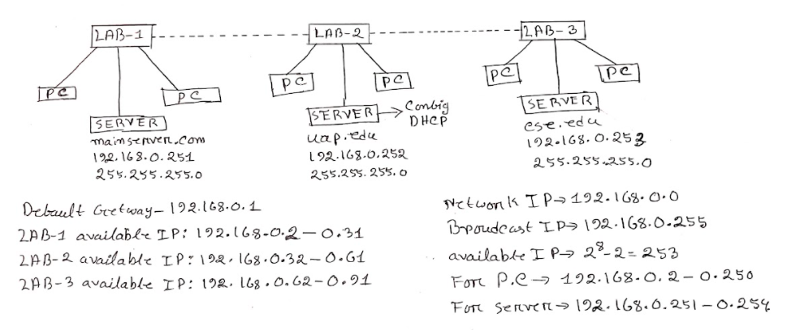

Now in Cisco Packet tracer we will implement our design. First we will put the necessary Switch, PC, Server. Then we will connect them. To connect our device, we will always remember that for the same type of device we need **copper cross-over** connection and for different type devices, we need to connect **copper straight-through** connection. So PC to Switch and Server to Switch connection will be straight through connection and Switch to Switch connection will be cross-over connection. Then we will note down the IP addresses of our connected PC & Server, Then we will rename the server and note down their IP addresses. Then we will identify LAB-1,2&3. Finally we will configure our devices. We will consider LAB-1’s server(main server) as Host Server.

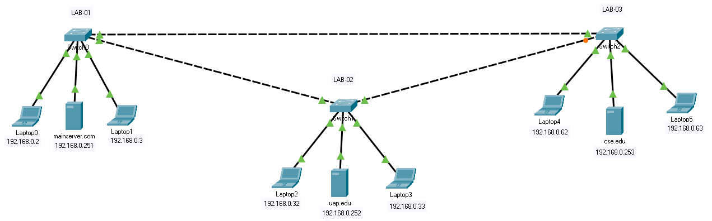

**PC/Laptop Configuration :**

First we will configure our PC. To configure our PC we will follow the mentioned steps below:

* Select a PC to configure. Then Desktop>IP Configuration.
* Here you will see a configure page. Fill up the IPv4(IP) Address according to the note. Default subnet mask will automatically fill up. Then set the Default Get way: 192.168.0.1(Mentioned in Network Structure). Then put the DNS server: 192.168.0.251

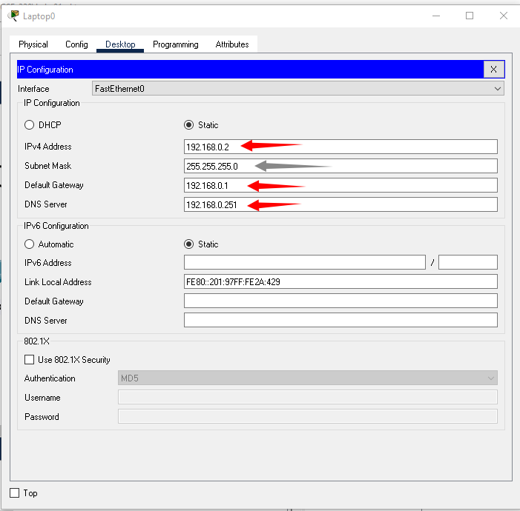

We will continue the same process for every PC/Laptop in our system. Then we will go for Server setup.

**Server Setup :**

* Select a server that you are supposed to configure.
* Go to Desktop > IP Configuration.
* Then you may see a configuration prompt.
* Insert IPv4 Address according to the note, Subnet mask will automatically set.
* Insert Default Getway: 192.168.0.1
* Continue the same process(IPv4 Address depends on the note) for Server-2&3.

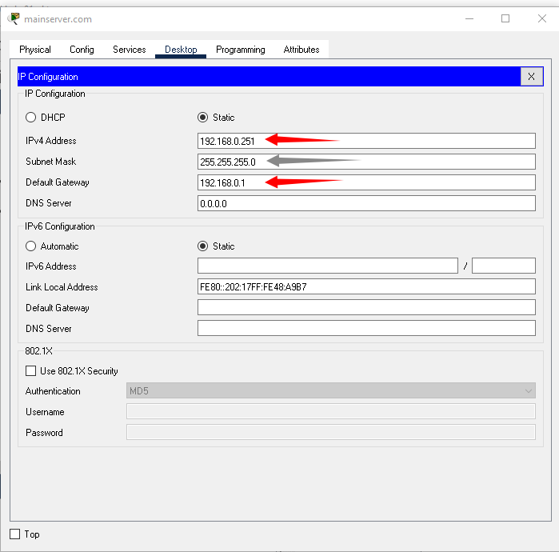

Now we well check, our devices are connected or not using the following steps:

* Select a PC/Laptop.
* Select Desktop> Command Prompt
* Write ping #IP_Address(Assigned IP) for say ping 192.168.0.252 or ping 192.168.0.33

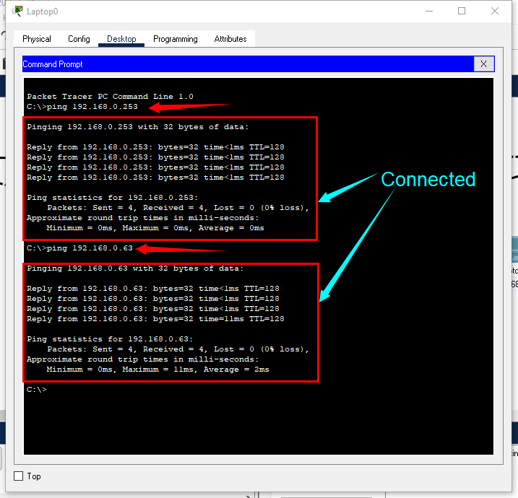

Now we will configure the DNS server. In the DNS server we will specify a site name for a specific server. Like as we said that we will consider Server-1(192.168.0.251) as [www.mainserver.com](http://www.mainserver.com) Server-2(192.168.0.252) as [www.uap.edu](http://www.uap.edu) and finally Server-3(192.168.0.253) as [www.cse.edu](http://www.cse.edu) we will just implement this in DNS so that any connected PC can visit the site when they are connected to the network. So we will configure Server-1 for DNS using the following steps.

**DNS Configuration :**

* Select SERVER-1. Then Services > DNS
* First ON the DNS. Then enter the Name(like [www.uap.edu](http://www.uap.edu) or [www.cse.edu](http://www.cse.edu) )
* Then enter the Address for say [www.mainserver.com](http://www.mainserver.com) - 192.168.0.251 [www.uap.edu](http://www.uap.edu) - 192.168.0.251 [www.cse.edu](http://www.cse.edu) - 192.168.0.253
* Then click the ADD button. And you can see the added Name bellow

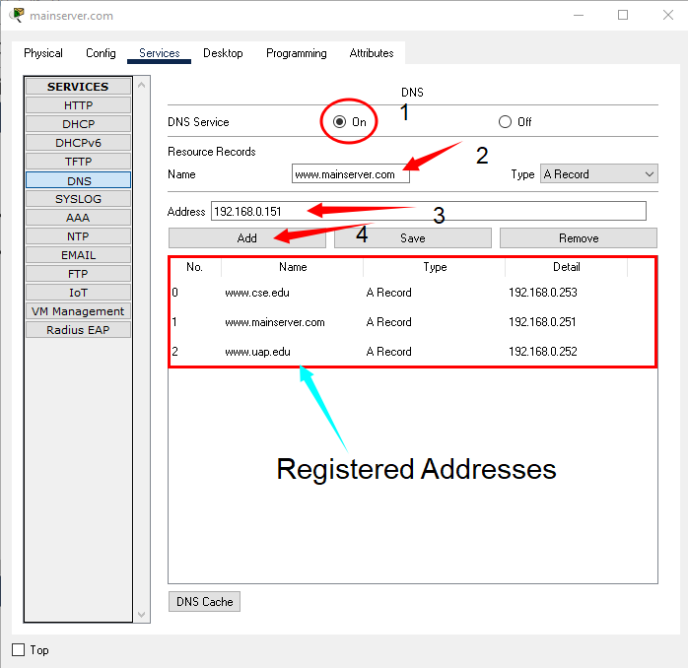

You can also configure the HTML part to specify what the page should show. For that just select a server. Then Services > HTTP where you can see a prompt to edit the following section to control what the site should show. You can do this for any server(Server-1,2&3)

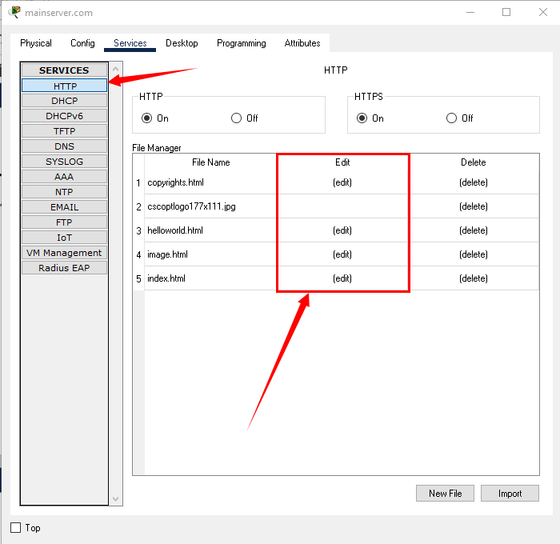

Now we will check, our DNS server is connected or not.

To identify this, we just need to select any PC connected to the network. Then we will select **Desktop > Web Browser**. Where you can see a web browser page. In the URL section we will search for one of our configured sites for say [www.cse.edu](http://www.cse.edu) and click Go or press enter. This will run a page. Which means that our DNS server is successfully configured. You can also check other added sites like [www.mainserver.com](http://www.mainserver.com) or [www.uap.edu](http://www.uap.edu)

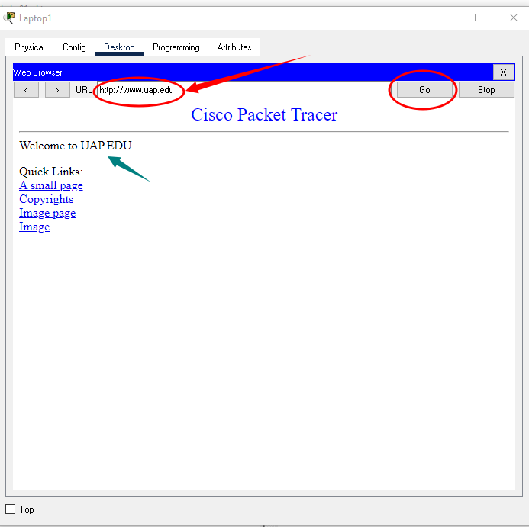

Now there is a problem. We have manually configured our PC/Laptop. Which is not a good idea. We are not supposed to insert IP address, Default Getway, DNS Server every time when a device wants to get connected with the network. Again it is not possible to remember every device IP address. So we need some configuration so that devices can automatically configure themselves and provide the Service.

This problem can be solved by using DNCP server. In this process, new connected device will get the ip address, default getway, DNS server by itself.

In our network we will configure Server-2 as a DHCP server. Remember one thing, a network may have many servers but it can’t have many DHCP servers. It will cause conflicts and create problems in the network system.

Follow the steps Below to configure DHCP server:

**DHCP Configuration :**

* Select Server-2, then select Services > DHCP
* On the Service
* Enter Default Getway and DNS Server. Subnetmask will automatically insert.
* Define the Maximum number of Users
* Then Click Save

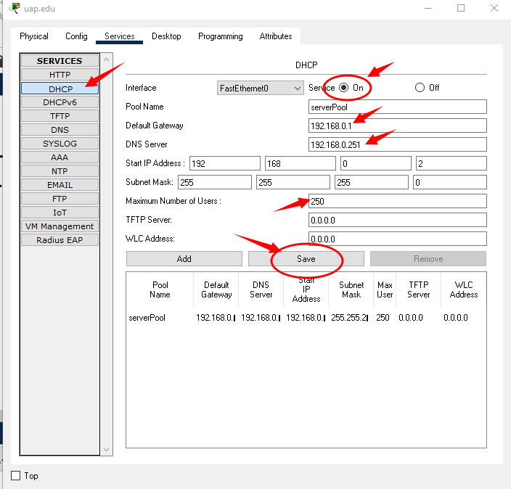

Now we need to check if our configuration is complete or not. For that we will add 2 new devices with the switch along with Server-2. First we will connect our new PC.

* Select one of the new devices. Click Desktop > IP Configuration.
* Select DHCP and wait for met moment
* Then you can see that your new pc automatically took the IP Address.

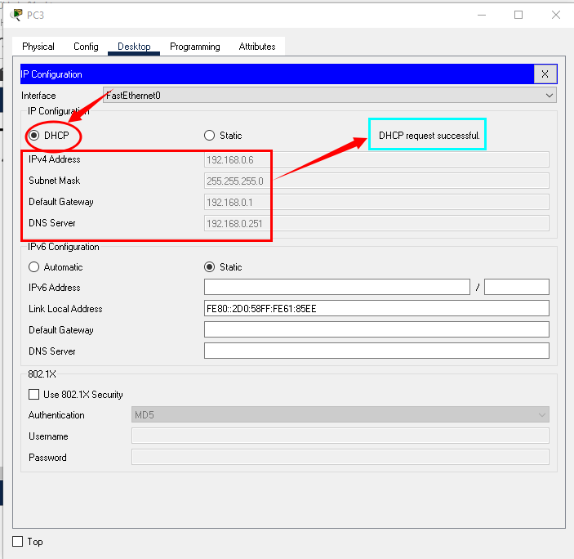

Do the same thing with another PC/Laptop and check if the connections are working properly or not.

**Final Design :**

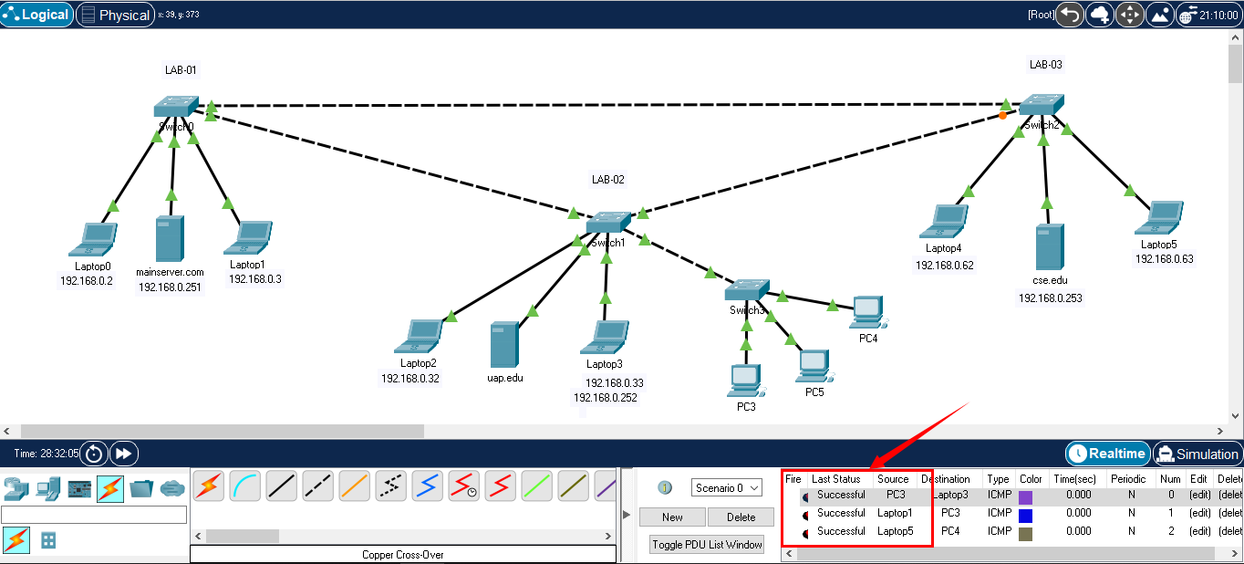

**Learning :**

In this experiment, we learned about DNS & DHCP servers. How to connect PC - Switch -Switch and configure PC, DNS server & DHCP server.

**Discussion:**

It may take some time to establish a connection. Please wait until the node of the connection turns green. Be careful with cross-over & Straight through connection. Same Type Device- Crossover, different type device: Cross-over connection. Send packages from PC to PC or use Command prompt to check the connection between devices. If there were any kind of error, check the IPV4 addresses. Try to use switch-2960 with 24-ports.